Testing Results Documentation
1. Purpose
The purpose of this document is to summarize the testing results of the Wind Turbine Energy Prediction project, covering model performance, application deployment, and API integration.

2. Test Execution Logs
Test 1 – Model Training
Command:
PS C:\Users\mahes\Downloads\WindEnergyProject\Project File> python train_model.py
Result:
- R² Score: 0.8673
- Model saved successfully (power prediction.sav).
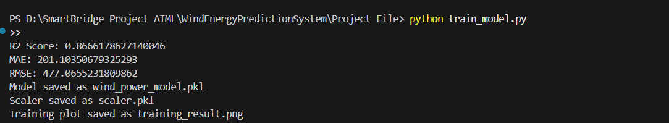
Conclusion:
The Random Forest regression model achieved strong predictive accuracy, indicating good generalization on validation data.

Test 2 – Application Deployment
Command:
PS C:\Users\mahes\Downloads\WindEnergyProject\Project File> python app.py
Result:
- Flask app started successfully.
- Running on: http://127.0.0.1:5000/
- Debug mode enabled.
- Debugger PIN generated.
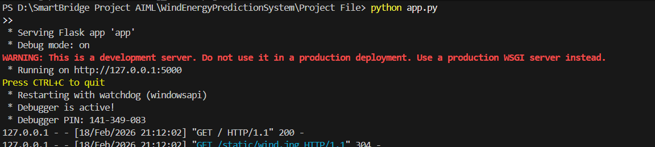
Conclusion:
The application backend is functional and accessible locally. Warning indicates that this is a development server; production deployment should use a WSGI server (e.g., Gunicorn).

Test 3 – API Integration
Action:
- Obtained API key from OpenWeather (https://openweathermap.org/).
- Integrated API key into app.py.
Result:
- Weather data successfully fetched (temperature, humidity, pressure, wind speed).
- Predictions generated based on live weather inputs.
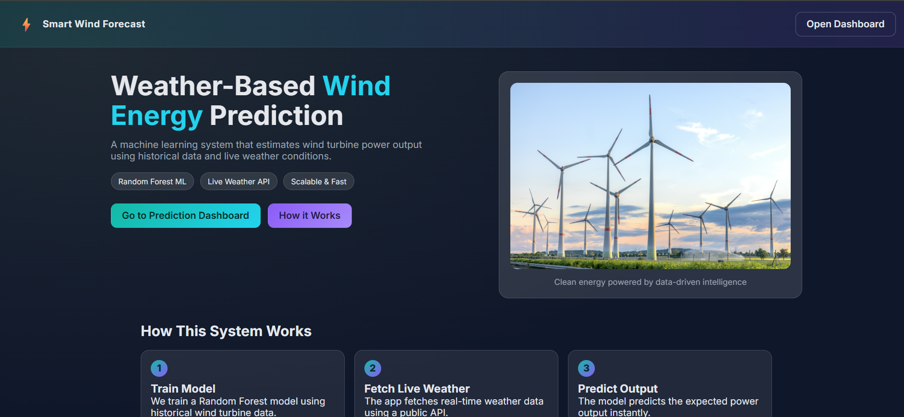
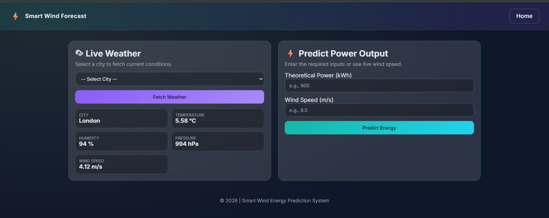
Conclusion:
API integration works correctly, enabling real-time data retrieval for prediction.

3. Summary of Testing
Test Case ID | Scenario | Expected Result | Actual Result | Pass/Fail
TC-001 | Model Training | Model trains and saves with acceptable accuracy | R² Score = 0.8673, model saved successfully | Pass
TC-002 | Application Deployment | Flask app runs locally without errors | App running at http://127.0.0.1:5000 | Pass
TC-003 | Weather API Integration | API key fetches live weather data | Weather data retrieved successfully | Pass
TC-004 | Prediction Output | Model generates predictions based on inputs | Predictions generated correctly | Pass

4. Conclusion
The testing phase confirms that:
- The ML model performs well with an R² score of 0.866, showing reliable predictive capability.
- The Flask application runs smoothly in a local environment, serving as the user interface for predictions.
- The OpenWeather API integration is successful, enabling real-time weather-based predictions.

